## Overview

In this activity, you will turn the default Bootstrap 4 jumbotron you have now into a professional-level, attention-grabbing image.

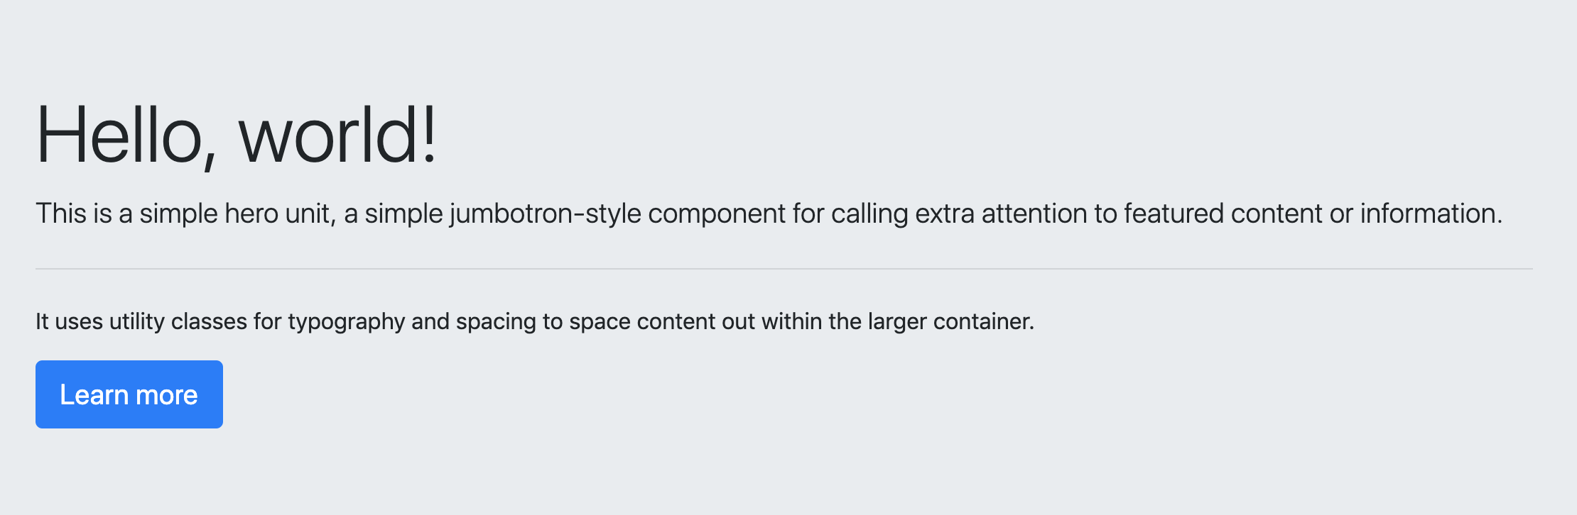

**⇩**



## Instructions

**Part 1: Update the HTML**

1. Add the rockBackground class to the jumbotron <div>.
   * Again, you will be using this class to style this element.
2. Add a new <div> with the class jumboCopy within the jumbotron <div>.
   * Move the jumbotron’s content within this new <div>.
3. Update the copy and button text in the jumbotron to reflect the design above.
   * **Note:** Feel free to add a more compelling description.

**Part 2: Update the CSS**

1. Add the following CSS within a selector that targets the jumbotron <div>:

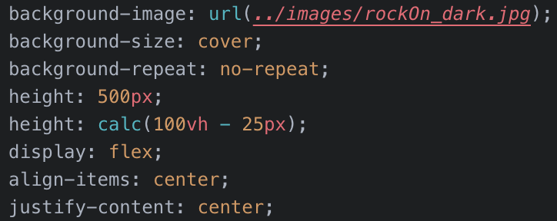

1. Add a selector for the jumboCopy class with the following properties and values:

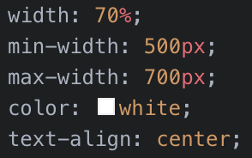

1. That’s it for this activity. You should now have a finished jumbotron.



Great work!